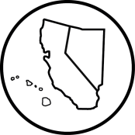
C N H | K E Y C L U B

College Park Key Club Board Meeting
California-Nevada-Hawaii District
Key Club International
February 15, 2017

- Call to Order: 2:51pm Adjournment: 3:06pm
  - Meeting led by Charissa Tseng
  - Pledge of Allegiance Brian Choe
  - Key Club Pledge Peter Tolentino
  - Introduction of Guests N/A
  - Quorum Present Yes
- Attendance- 6 officers
- Old Business
- New Business
  - Secretary – send minutes
  - Vice Presidents – find service events
- Open Floor
- Adjournment: 3:06pm
Minutes Approved by Club President
Minutes Approved by Club Secretary
Minutes Approved by Faculty Advisor

C N H | K E Y C L U B
Attendance
Attendance for this Board meeting was completed by Pierce Bargmann .
*This attendance sheet is used for present officers, Kiwanis, and guests only.
Officers
President Charissa Tseng
Vice President 1 Peter Tolentino
Secretary Pierce Bargmann
News Editor Brian Choe
Designer 1 Katherine Chong
Designer 2 Emily Nguyen

