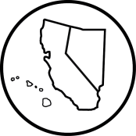
C N H | K E Y C L U B

College Park Key Club Board Meeting
California-Nevada-Hawaii District
Key Club International
November 15, 2016

- Call to Order: 3:03pm Adjournment: 3:54pm
  - Meeting led by Charissa Tseng
  - Pledge of Allegiance Emily Nguyen
  - Key Club Pledge Emily Nguyen
  - Introduction of Guests N/A
  - Quorum Present Yes
- Attendance- 6 officers
- Old Business
- New Business
  - Count money from Trick or Treat for UNICEF boxes
- Open Floor
- Adjournment: 3:54pm
Minutes Approved by Club President
Minutes Approved by Club Secretary
Minutes Approved by Faculty Advisor

C N H | K E Y C L U B

Attendance
Attendance for this Board meeting was completed by Pierce Bargmann .
*This attendance sheet is used for present officers, Kiwanis, and guests only.
Officers
President Charissa Tseng
Vice President 1 Peter Tolentino
Vice President 2 Amy Nguyen
Secretary Pierce Bargmann
News Editor Brian Choe
Treasurer Mani Lopez

